**Logistics Performance Index (LPI) Case Analysis**

**Canada**

Ebony Edwards

Ma Cristina Garcia

Yu Ming Liu

John Adongo

Srijani Chakraborty

Arizona State University

SCM 516: Descriptive & Predictive Analysis

Professor [Surya Ayyalasomayajula](https://canvas.asu.edu/courses/202929/users/840047)

This study examines the trends in Canada’s Logistics Performance Index (LPI) from 2007 to 2023, with a focus on the key factors driving improvements in its score. Using World Bank data, we will analyze the six primary components of the LPI—customs, infrastructure, international shipments, logistics competence and quality, tracking and tracing, and timeliness—to identify which factors have most significantly influenced Canada’s LPI advancements. By assessing these indicators, we aim to determine how best to sustain and enhance Canada’s LPI score, employing a robust regression model to explain the relationship between each component and the overall LPI score.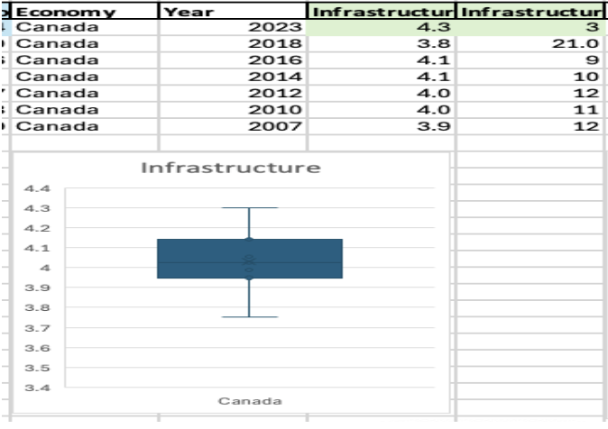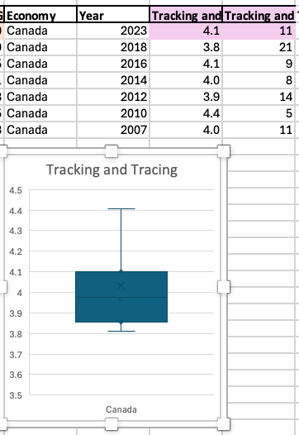

*The box-and-whisker plots presented above depict the Tracking and Tracing, Infrastructure Score component for Canada*

Infrastructure Score and Tracking and Tracing Score are the top 2 indicators that will be tested on. The first plot indicates that Canada’s median Infrastructure is 4.02, with a maximum score of 4.3 and a minimum score of 3.75 The lower quartile (Q1) is 3.9, indicating that 25% of the data falls below this value while the upper quartile (Q3) is 4.14, indicating that 75% of the data lies below this value. The mean value for this plot, signified by ‘X’, is 4.03. Since the mean and median values are close in value, it can be inferred that the data is relatively symmetric. As shown by the graph, the tails are of similar length, indicating a balanced distribution with no significant skewness. The second plot shows that Canada’s median Tracking and Tracing score is 3.97, with a maximum score of 4.4 and a minimum score of 3.8 The lower quartile (Q1) is 3.85, meaning that 25% of the data falls below this value, while the upper quartile (Q3) is 4.1, indicating that 75% of the data falls below this point. The mean, represented by ‘X’, is 4.03. The distribution of values appears to be positively skewed, as suggested by the longer whiskers on the upper side of the median.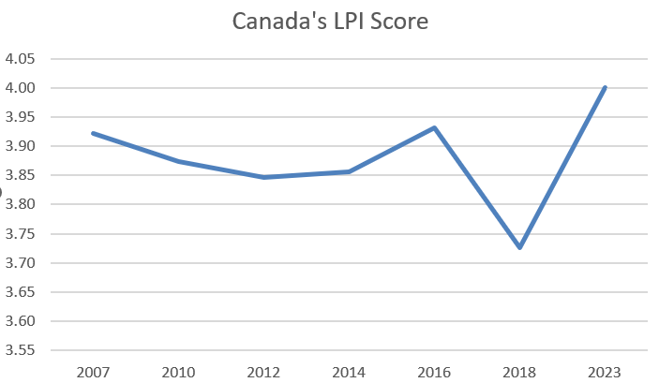

*Drastic increase in LPI score from 2018-2023.*

What might have led to the drastic increase in Canada’s LPI score from 2018 to 2023? To analyze the relationship between Infrastructure Score and Tracking and Tracing Score, we will examine data from the top 20 countries with the highest LPI scores in 2023.

* Null Hypothesis (H₀): There is no correlation between Infrastructure Score and Tracking and Tracing Score i.e R=0
* Alternative Hypothesis (H₁): There is a statistically significant correlation between Infrastructure Score and Tracking and Tracing Score i.e R!=0

For this study, significance level is at α= 0.05. A two tailed t- test is conducted for this study. First step is finding the correlation coefficient by using this excel formula =CORREL(#infrastructure score data, #tracking and tracing score) which results to 0.322. The total sample size is 20. Using t = R√(N-2) / (1-R^2), the t statistic is =1.441. The next step is to find p-value. By using this excel formula =T.DIST.2T(t statistic, N-2), p- value= 0.167. Since the p-value is greater than the significance level(α= 0.05), we fail to reject the hypothesis. To double check this, a scatterplot was conducted to find the linear regression. The R2= (0.1034), the scores are not correlated to each other. Since we did not find a strong relationship between Infrastructure and Tracking and Tracing scores, we examined their individual relationships with Canada’s LPI score. With an R-squared value of 0.797, the results show a high level of correlation between these combined scores (Infrastructure and Tracking and Tracing) and the overall LPI score. 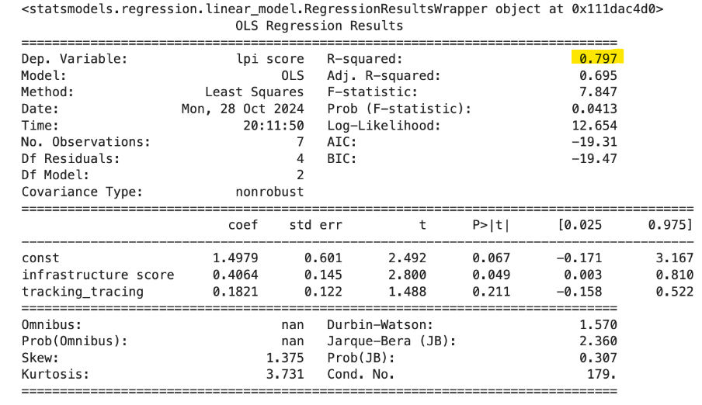

As observed from the pictures above. In the second row to the left, there is a strong linear relationship between Infrastructure Score and LPI Score. In the second row to the right, there is a relatively weaker linear relationship between Tracking and Tracing Score and LPI Score. Hence, we can conclude that Infrastructure Score of Canada has had a major impact on the increase of its LPI score. The researchers have come up with recommendations in order to increase Canada’s LPI Score. The following are: 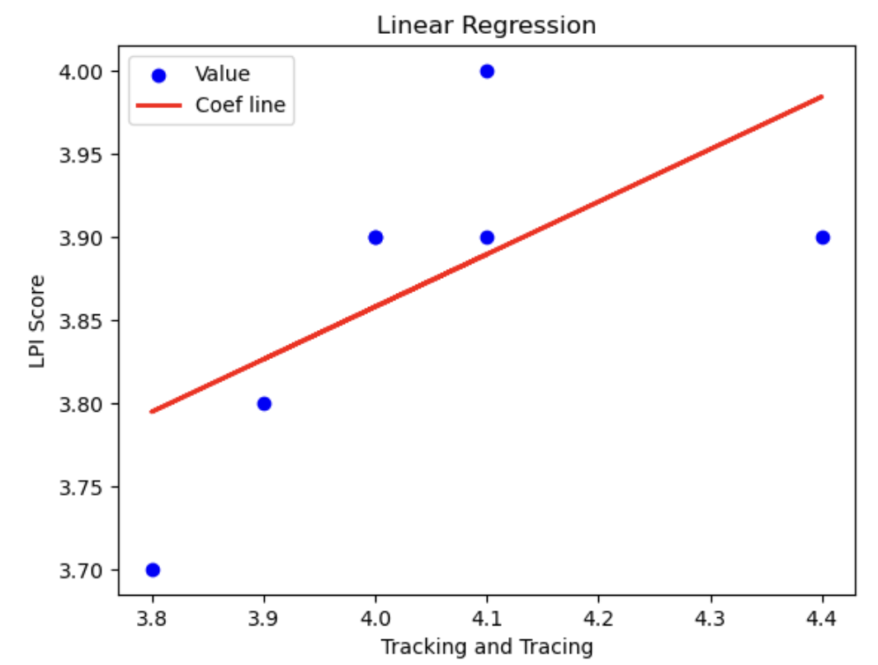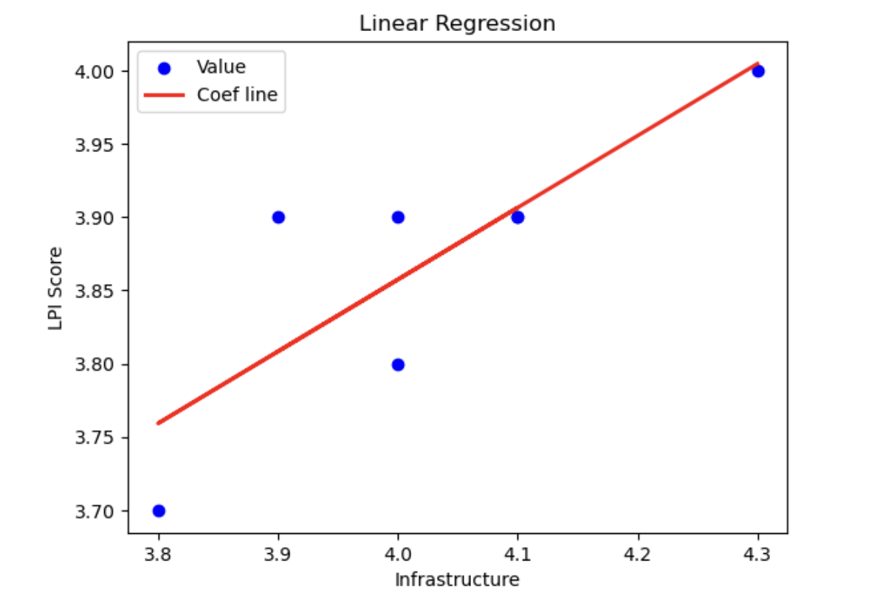

* Invest in Infrastructure- Enhance transportation infrastructure, such as roads, railways, and ports, focusing on upgrades and maintenance. This includes modernizing facilities and expanding capacity to handle increased freight volumes.
* Adopt Smart Technologies- Implement advanced technologies like IoT and AI for real-time tracking and monitoring of logistics operations. This can improve efficiency and reduce delays in the supply chain.
* Enhance Connectivity- Improve intermodal connectivity to facilitate smoother transitions between different modes of transportation, making it easier for goods to move across the country.